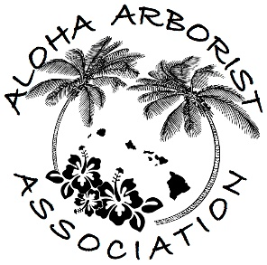
Aloha Arborist Association
Monthly Meeting
August 19th, 2020, 6:30PM
Zoom Link Here

In Attendance: Desiree Page, Carol Kwan, Tylor Schwarz, Angela Liu, Jolie Dollar, Philippe Visintainer, Kevin Eckert
Call to order: 6:44pm

- Call to Order and Approval of Draft July 2020 Meeting Minutes
Tabled
- Welcome Guests and Members
Philippe Visintainer (member): Hawaii Coconut Protectors
- Reports of Officers and Standing Committees
  - Treasurer’s Report - tabled
  - Training Committee
    - Training event Calendar
      - Tree Care for Birds and Wildlife Webinar Series – Earn CEUs – Register Here
        - White Tern Training: Thursday (tomorrow), Aug. 20 from 8:00-9:30 am
        - Hawaiian Hoary Bat Training: Aug. 27 from 8:00-9:30 am
      - ISA exams (All Levels): Saturday, October 10, 2020 @ Paki Hale
        - Need to apply now and then register for exam
      - Proper Pruning – Webinar featuring Dr. Jim Downer: Wednesday, Nov. 4, 2020 - Register
        - $10 COVID-19 Limited Time Discount, 1.0 ISA CEU
      - Free On-Demand Webinars – Coordinating Group on Alien Pest Species (CGAPS)
        - Examples of webinars: Biocontrol on Strawberry Guava, Little Fire Ants in Hawaii
    - Webinar on Diagnosis/Treatment of Pests & Diseases,
        - Christopher Luley – Wood Decay Fungi
          - General, introductory info about fungi
          - Include risk assessment of palms; fungi as it pertains to risk assessment / tree failure
          - Action Item: Jolie to send survey to gauge interest from members / others
        - Other ideas:
          - COVID safety
          - Action Item: Jolie to question membership about how COVID is affecting work, employee retention, etc.
    - Open Chair position
  - Jamboree Committee
    - Progress update
    - Discussion about location at Lyon Arboretum; Tylor to investigate further

- Unfinished Business and General Orders
  - Revisiting our Vision Statement and Mission Statement
    - Action Item: Jolie to get vision and mission statements from ISA and Western Chapter to compare.
    - Action Item: Carol to send her recommendations (attached at the end of the minutes)
- Educational Discussion
  - New Invasive Planthoppper
    - From DOFAW entomologists: “From our entomologists: It was found at the end of Palehua road last week. The species isn't 100% confirmed yet but it appears to be Scolypopa australis, which is an invasive pest in New Zealand and has a very wide host range. So far they seem to be mostly limited to the north side of Mauna Kapu, but we are not yet sure. It has the potential to be a problem in both native forest and agriculture, so it would be good to let people know to look out for it.”
    - If seen, people should call 643-PEST Hotline Call the statewide pest hotline, 643-PEST (808-643-7378), which will direct you to the nearest Department of Agriculture.
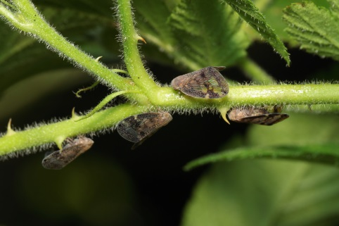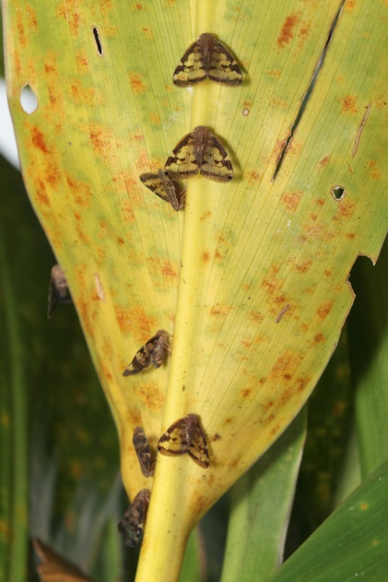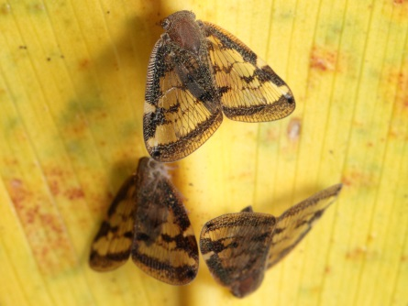

  - Chipper Safety – Winch accident on Big Island
    - What Happened? What could have happened? How do we keep it from happening to us?
    - HiOSHA Officer looks for root cause
      - Fed osha doesn’t have any specific guidance for chipper operation in our industry. They would refer to industry or ansi recommendations
        - General duty clause – no rules but the danger is recognized and addressed in other ways (ie: the operators manual, ISO SOP’s, ANSI Standards)
      - When investigating the root cause of an incident, the 4 things they will check that are the employer’s responsibility (not necessarily limited to)
        - What responsibility or activity was being performed with what equipment
        - How was the victim trained regarding this job, specific activity, equipment
        - How is the employer determining employees understand/practice this training – audit
        - How does the employer respond to discovered noncompliance
      - * most important thing is employer and employee “knowing the operators manual thoroughly.
    - Action Item: Jolie to gather info about AAA’s previous work with OSHA and HIOSH and gather ideas about how to reconnect with them.
    - Discussion about how to best reach arborists who are most at risk: Saturday morning programs (TV, radio); social media. Potential for outreach to community colleges; high school career days; FFA; etc.

- Announcements
  - Please Join Us On:
September 16th, 6:30PM – Monthly Meeting – Location: Zoom
Adjourn at 8:30 PM

Attachment:
AAA Vision and Mission
Carol’s version

Vision statement:

AAA’s vision is for Hawaii to have a thriving urban forest that is cared for safely and properly and is valued and appreciated by its residents.

Mission statement:

AAA fosters the appreciation of Hawaii’s urban forest by educating the industry and the public and safe, proper tree care. It does this by:

- Providing public education about the benefits of the urban forest and the value of proper, professional maintenance
- Stimulating greater public interest in planting and preserving the urban forest and the environmental benefits it provides
- Supporting industry professionals by providing education on safe work practices and national maintenance standards
- Encouraging credentialing of industry professionals and providing opportunities for Continuing Education Units for credential holders
- Staying up-to-date with current arboricultural information and serving as a communication channel to disseminate the information to others
- Recommending and upholding the ISA’s “Code of Ethics”

