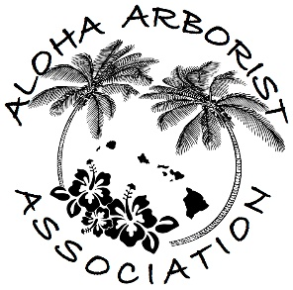
Aloha Arborist Association
Monthly Meeting
July 22nd, 2020, 6:30PM
- Via Zoom -

- Call to Order and Approval of May and June 2020 Meeting Minutes

- Welcome Guests

- Reports of Officers and Standing Committees
  - Treasurer’s Report
  - Training Committee
    - Training event Calendar
      - Progress Update
    - Webinar on Diagnosis/Treatment of Pests & Diseases,
        - Christopher Luley – Wood Decay Fungi
    - Open Chair position
    - Recap/ fill us in
      - Matt Ritter’s Hawaii Island Selectree Database presentation
      - Eucalyptus Webinar
  - Jamboree Committee
    - Progress update

- Unfinished Business and General Orders
  - Board elections
    - Slate of Nominees
      - Past President – Dudley Hulbert
      - President – Desiree Page
      - Vice President – Sergio Vasquez
      - Secretary – Angela Liu-Kelley
      - Treasurer – Carol Kwan
      - Director – Justin Barrios
      - Director – Carin Prechtl
      - Director – Tylor Schwarz

- New Business
  - Revisiting out Vision Statement and Mission Statement
    - A mission statement is intended to clarify the what, who, and why of a company. On the other hand, a vision statement describes where the company wants a community, or the world, to be as a result of the company's services. A mission statement is the roadmap for the company's vision statement.
  - Kaulunani Council’s Policy Committee would like to poll AAA’s membership regarding tree related ordinances

- Educational Discussion
  - Chipper Safety – Winch accident on Big Island
    - What Happened? What could have happened? How do we keep it from happening to us?
    - HiOSHA Officer looks for root cause
      - Fed osha doesn’t have any specific guidance for chipper operation in our industry. They would refer to industry or ansi recommendations
        - General duty clause – no rules but the danger is recognized and addressed in other ways (ie: the operators manual, ISO SOP’s, ANSI Standards)
      - When investigating the root cause of an incident, the 4 things they will check that are the employer’s responsibility (not necessarily limited to)
        - What responsibility or activity was being performed with what equipment
        - How was the victim trained regarding this job, specific activity, equipment
        - How is the employer determining employees understand/practice this training – audit
        - How does the employer respond to discovered noncompliance
      - * most important thing is employer and employee “knowing the operators manual thoroughly.
- Announcements
  - CTW / CA exam makeup on August 8th
  - Please Join Us On:
August 19th, 6:30PM – Monthly Meeting – Location: Zoom

